# p.prudhvi sai krishna

2000080083

# Fuzzy logic controller

## ABSTRACT:

Mamdani fuzzy inference was first introduced as a method to create a control system by synthesizing a set of linguistic control rules obtained from experienced human operators [[1].](https://in.mathworks.com/help/fuzzy/types-of-fuzzy-inference-systems.html#mw_12c3a6dc-fee1-4065-b64a-9fd2ac57d6ef) In a Mamdani system, the output of each rule is a fuzzy set. Since Mamdani systems have more intuitive and easier to understand rule bases, they are well-suited to expert system applications where the rules are created from human expert knowledge, such as medical diagnostics.

The ‘tipping problem’ is commonly used to illustrate the power of fuzzy logic principles to

generate complex behavior from a compact, intuitive set of expert rules. **USAGE:**

* **If I tell this controller that I rated:** • the service as 9.8, and the quality as 6.5,
* **it would recommend I leave:**
* a 20.2% tip.

**METHODOLOGY:**

We would formulate this problem as:

* **Antecednets (Inputs)**
* **Service:**

### Universe (ie, crisp value range): How good was the service of the wait staff, on a scale of 0 to 10?

o Fuzzy set (ie, fuzzy value range): poor, acceptable, amazing

### Quality:

* Universe: How tasty was the food, on a scale of 0 to 10?

### Fuzzy set: bad, decent, great

•

* **Consequents (Outputs):**
* **Tip:**

### Universe: How much should we tip, on a scale of 0% to 25%

* Fuzzy set: low, medium, high RULES:
* IF the service was good or the food quality was good, THEN the tip will be high.

### IF the service was average, THEN the tip will be medium.

* IF the service was poor and the food quality was poor THEN the tip will be low.

## OUTPUT:

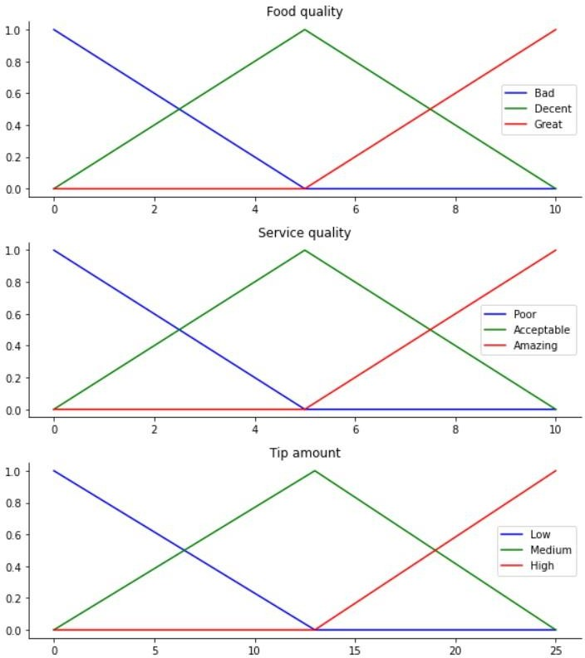

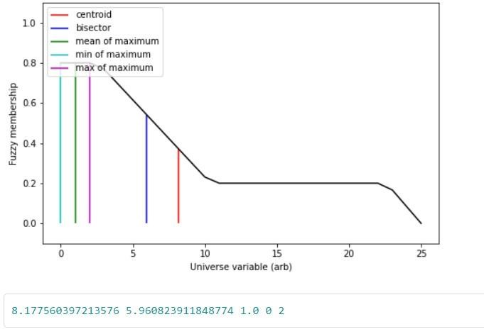

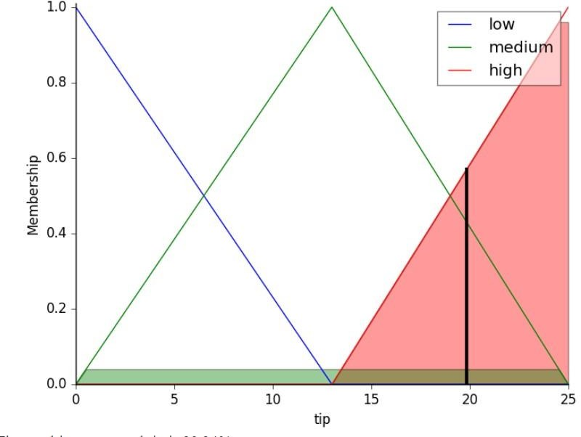

**CONCLUSION:**

The power of fuzzy systems is allowing complicated, intuitive behavior based on a sparse system of rules with minimal overhead. Note our membership function universes were coarse, only defined at the integers, but fuzz.interp_membership allowed the effective resolution to

increase on demand. This system can respond to arbitrarily small changes in inputs, and the processing burden is minimal.

**LINK(GITHUB):**